Network preparation

1 Network Architecture
Revised from 2_power_grid_simplification.ipynb
We developed the network simplification and representation based on GridTool, which is a tool to convert and simplify electricity grid data from OpenStreetMap (OSM) for the use in power simulation models and is developed in MATLAB.
- Aim:
- Input data: `vietnam-latest_lines.gpkg`: saved power lines extracted from OSM
- Outputs: two excel files indicating the lines and nodes of power network

1.1 Module 1: Import data
Revised from 1_osm_preparation.ipynb
- Aim: extract power infrastructure (i.e., power plants/generators, substations, and power lines) from OpenStreetMap
- Package: osm-flex
- Input data: `vietnam-latest.osm.pbf`, downloaded on xx May 2024. We chose this kind of out-of-dated data is because we only have the electricity statistics until 2023,
Step 1: Extract power infrastructure from OSM and simplify by removing duplicated assets.
Step 2: Add osm_id to substations extracted from `vietnam-latest.osm.pbf`.
Step 3: Save files as gpkg files.

1.1.1 load_osm_data

1.1.2 import_osm_infras
Filter geometries based on column values and save to file.

1.1.3 add_missing_osm_ids
Add missing OSM IDs to a target GeoDataFrame using a reference GeoDataFrame via spatial join.

# Use the functions above OR read GeoPackage data directly:
lines = gpd.read_file("../data/osm/line.gpkg", epsg=32648, driver='GPKG')

1.2 Module 2: Data analysis

1.2.1 extract_unique_endpoints
Extract unique start and end coordinates from each LineString in a GeoDataFrame.

1.2.2 add_endnodes_to_lines
Add node1 and node2 columns to the geodataframe of the original lines data, and calculate the length, taking into account a slack factor of 1.2.

1.2.3 transform_osm_subs
Convert the linestrings to polygons, then add a 1000-meter buffer to both the polygons and points.
2.3.1 transform_geometry
2.3.2 linestring_to_polygon

1.2.4 add_osm_ids_to_nodes
This function updates a DataFrame with OSM (OpenStreetMap) node IDs and geometry information for nodes that fall within a specified geographical area, represented by `osm_subs`.
2.4.1 get_osm_info_for_point

1.2.5 count_voltage_levels
The function `count_voltage_levels` reads the voltage information from the source file and adds it to the way elements. If there are lines with different voltage levels going between two nodes, they are displayed as one way-element with different voltage levels in the OSM-data. This function identifies the lines with multiple voltage levels and clones these to make separate lines for each voltage level. After that the number of way-elements for each voltage level are counted.

1.2.6 delete_busbars
The function `delete_busbars` goes through every way-element and checks if it has a tag that declares it as a busbar or bay. If the beeline length of the way element is smaller than the length set in busbar max length, then the element is deleted. If the busbar or bay has a length greater than busbar max length a message is printed so the user can have a closer look into it. In this case, the busbar is included in the data set and considered as a normal line. This process is shown in Figure 1 picturing the detailed OSM-data of a substation and lines after removing all busbars and bays.
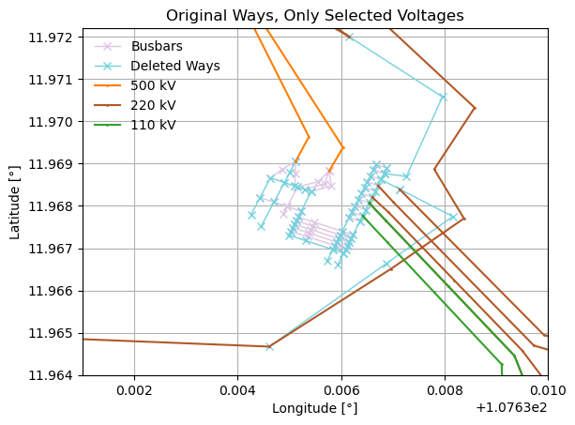
Figure 1

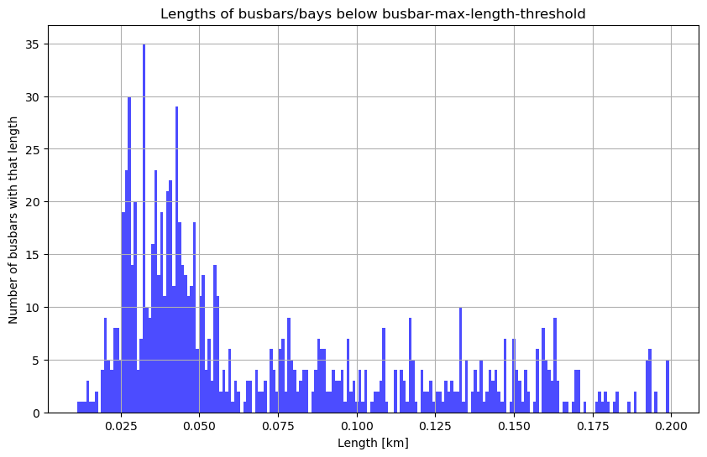
Figure 2

1.2.7 count_possible_dc
As direct current (DC)-lines might need special considerations (e.g. different line parameters compared to alternative current (AC)-lines) the function `count_possible_dc` looks for three signs to identify DC-lines: It only has one cable, the frequency is “0”, or the name of the line contains the phrase ’dc’. If one or more of the three conditions are true, “potentially DC” is added to the notes field of the way-element in the final result.

1.2.8 count_cables
The last function in this module `count_cables` counts the number of systems per way-element. The OSM-data contains information about the number of cables on a way-element. If it is a standard AC-system, three cables are needed for one system, six cables for two systems and so on. This function goes through every way-element and checks the number of cables. A new field “systems” is added to the data set for way-elements. This contains the number of systems that can be derived from the number of cables. For way-elements that have ‘3’, ‘6’, ‘9’ or ‘12’ cables the “systems” field is automatically set to ‘1’, ‘2’, ‘3’ or ‘4’ respectively. If a way-element has more than one voltage level (and so the tool doesn’t know which of the voltage levels has how many systems) or if there are way-elements with number of cables other than the ones mentioned above a warning is displayed in the printed results. The number of systems is later used in the function `add_lineID_clone_ways` to double, triple or quadruple the line.

1.3 Module 3: Group nodes
The fourth module is the most important one. It consists of seven functions that heuristically find concentrations of nodes that are typical for power stations and groups them together.

1.3.1 calc_distances_between_endpoints
To identify nodes that can be grouped together based on their proximity, the distances between all nodes must be known. The function `calc_distances_between_endpoints ` creates a matrix with the all way-elements and their end nodes in the column headers as well as in the row headers. The distances between the end nodes are the values of the matrix. As the distance from end node 1 of way 1 to end node 1 of way 2 is the same the other way around, the resulting matrix is diagonal symmetric. Therefore, all elements below the diagonal in the matrix are set to “NaN” as they do not add any value. Elements in the diagonal are set to ‘-1’ as they either represent the distance between the same end node of a way (e.g. distance of end node 1 of way 1 to itself) or the distance between end node 1 of way 1 to end node 2 of way 1, which is the (already calculated) beeline length of the line. Only the distances between the end nodes above the diagonal are calculated using an efficient and fast matrix-calculation. To better understand this, Figure 3a shows an example of two way-elements: way 1 and way 2 each with the corresponding end nodes 1 and 2. This creates the matrix displayed in Figure 3b. The values in the diagonal are set to ‘-1’ (green paths in Figure 3a) and the values below the diagonal are set to ’NaN’ (red paths in Figure 3a). The distance calculated between end node 1 of way 1 and end node 1 of way 2 is A1 and so on. Therefore, a matrix with all the distances between all end nodes is created.
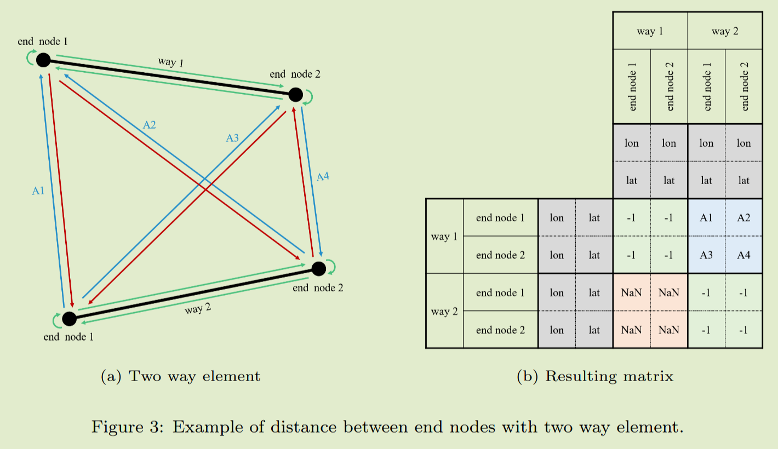
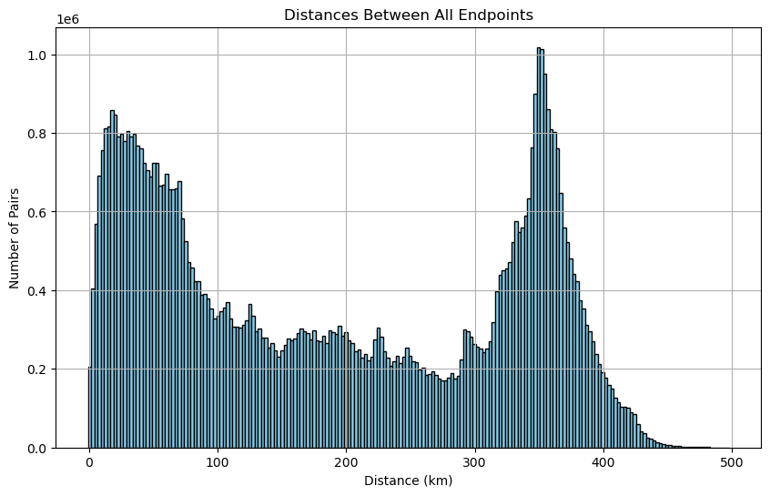
Figure 3

1.3.2 calc_stacked_endnodes
The function `calc_stacke_endnodes` goes through this matrix and searches for combinations where the distance between two endpoints is exactly ’0’ (stacked nodes). A list with all pairs of these end nodes is created.
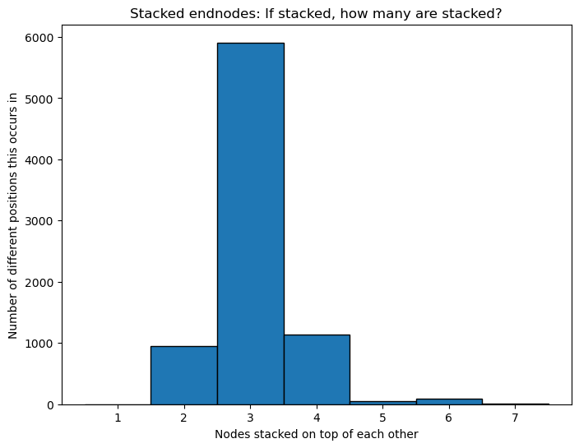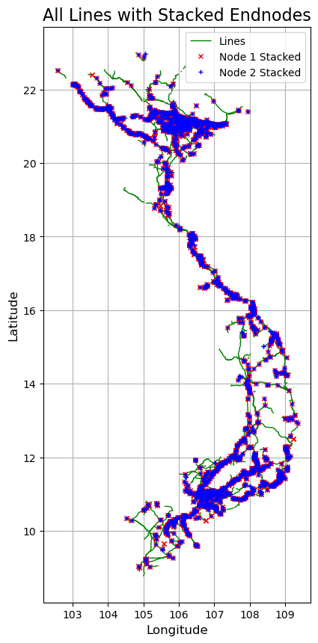

1.3.3 group_nodes
The function `group_nodes` is run two times, with the lists created by the functions above. It goes through those lists of paired end nodes and groups them. For example, the function `calc_stacke_endnodes`just says that endpoint A is stacked with endpoint B. But endpoint B could also be stacked with endpoint C. The function `group_nodes` will then group those three nodes together and the result is a list with nodes that should be condensed to one node.

1.3.4 group_stacked_endnodes
In the function `group_stacked_endnodes` the first node of each stacked group from the resulting list of `group_nodes` replaces all the other nodes in this list in the way-elements, meaning that two ways that had different end nodes ending in the same power station have the same end node now (if they have the same voltage level).

1.3.5 add_final_coordinates
The last function ` add_final_coordinates ` in this module updates the original data set and replaces end nodes that got grouped with the coordinates and IDs of the grouped nodes.
TODO: Add a visualization representing the distance threshold. All end nodes within a circle will be grouped togerther

1.4 Module 4: Export
The result is prepared and exported into two Excel-files: One containing all the nodes and the second one all the lines. and two GeoPackages??

1.4.1 delete_singular_ways
Before the export process starts, the function `delete_singular_ways` deletes lines that got condensed into “singular” ways (same start and end node) after grouping.

1.4.2 add_lineID_clone_ways
In the next step, the function `add_lineID_clone_ways ` clones way-elements based on the number of systems (see section Module 3: Data analysis). Furthermore, this function creates a unique ID for the lines that is used in the final Excel file. In its current form the ID is composed of the letters ‘LineID’, a country code that can be set in the variable export excel country code and a four-digit number starting at ’0001’. Way-elements that get cloned get the same ID, but a suffix added in the form of ’a’, ’b’, ’c’.
TODO: Add examples of the final excel sheets.

1.4.3 fill_line_voltage

This function assigns voltage to lines that don’t have voltage based on the nodes they connect to. It also removes lines without voltage levels. Out of 6,652 lines, 6,150 lines are retained.

1.4.4 export_data
The last function `export_data` exports the final data into two Excel files and two GeoPackages. It also creates unique IDs for the nodes, that are used in those results. The Excel file containing the node information has the columns NodeID (unique ID of the nodes), Country (country code set by export excel country code), Voltage (voltage level of the node in kV), lat (latitude of node in °) and lon (longitude of node in °). The Excel file containing the line data has the actual information is stored in the following columns: LineID (unique line id), Country (country code set by export excel country code), fromNode (start node of the line), toNode (end node of the line), Voltage (voltage level of the line in kV), Length (line length in km), Note (additional information). The sheet also has some pre-defined columns that have a value of ’0’: R (resistance), XL (inductive reactance), XC (capacitive reactance), Itherm (thermal limit current) and PhiPsMax (maximum phase shifting angle). Those values are important for load flow calculations, but OSM does not provide values for those. It is up to the user to come up with plausible values.

1.4.4 Complete the voltage information
Complete the `Voltage` columns in output excel files by adding data where it's missing.
How: Open the gpkg files, look for lines missing voltage data, trace the line and fill the voltage of its connected line to the voltage itself.

2 Electricity generation distribution
Revised from 3_electricity_generation_distribution.ipynb

2.1 Input data
1. ‘yearly_full_release_long_format.csv’
This dataset contains yearly electricity generation, capacity, emissions, import and demand data for over 200 geographies from 2020 – 2023. Data is collected from multi-country datasets (EIA, Eurostat, BP, UN) as well as national sources (e.g China data from the National Bureau of Statistics). Detailed description refers to the Data Methodology document on the website.
2. OSM generators.
3. Nodes created by network simplification, representing buses in the power model.

2.2 Add information to generators
Energy source, installed capacity, and electricity generation
For power flow model, we need to know the installed capacity and electricity demand of each generator. In the generator data we extracted from OpenStreetMap (OSM), there are power plants and generators, some of them have installed capacity data already, but there is no electricity generation data available. To distribute the total statistic amount to generators that don’t have these data, we need to know their energy sources, since ‘yearly_full_release_long_format.csv’ provides the data by fuel types.
We perform the following operations on generators:
- Combine the existing energy source and installed capacity of both power plants and generators in original OSM data.
- Count the unique values in the 'energy_source' column.
Unique energy sources: ['hydro' 'coal' 'wind' 'biofuel' 'diesel' 'biogas' 'gas' 'solar' 'substation' 'gas;oil' 'oil' 'waste']

- Map the energy sources in OSM to fuel types in the statistical data:
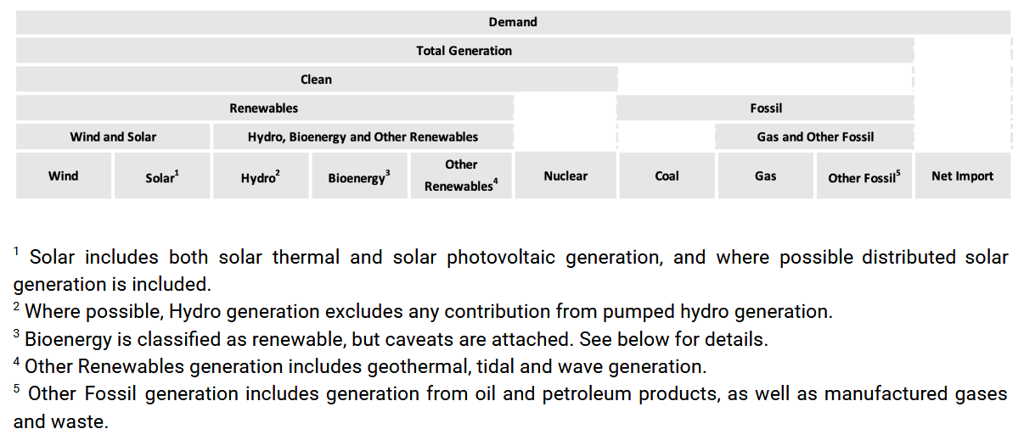
Figure source: Ember data methodology document (https://ember-energy.org/data/yearly-electricity-data/)
In Ember dataset, ‘Other Fossil’ type only has electricity generator without capacity, so we use the capacity of sum of ‘FO fired’ and ‘Diesel’ in Vietnam Energy Statistics.
OpenStreetMap | Ember Climate | Vietnam Energy Statistics
Waste, biofuel, biogas | Bioenergy | Biomass
Coal | Coal | Coal-fired
Gas, gas;oil | Gas | Gas fired
Hydro | Hydro | Hydro
/ | Nuclear (-) | /
Oil, diesel | Other Fossil | FO fired, Diesel
Solar | Solar | Solar
Wind | Wind | Wind

Fuel types | Capacity (GW) | Electricity generation (TWh)
Bioenergy | 0.38 | 0.85
Coal | 27.24 | 129.58
Gas | 8.15 | 26.32
Hydro | 22.64 | 80.9
Nuclear (-) | 0 | 0
Other Fossil | 1.603 | 1.72
Solar | 17.08 | 25.7
Wind | 5.89 | 11.37

- Counts the number of generators per 'energy_source'.
- Allocate capacity
  - Counts the number of generators per 'energy_source' with and without 'installed_capacity'
  - For generators with 'installed_capacity', calculates the total and average values, for validating whether the installed capacity allocation is reasonable.
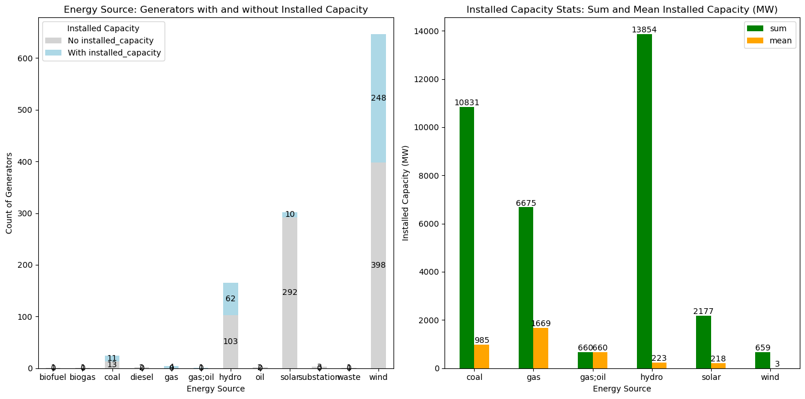
Figure 4

  - Keep rows in the generator dataset where energy source are present no matter capacity is missing or not. Remove rows where energy source is missing, no matter capacity is present or not.
Result: remove 26 rows.
  - Split the filtered generator dataset into two groups, group1 with capacity and group2 without capacity. Subtract the sum of capacity in group1 from total capacity by energy source. Allocate the remaining capacity to group2 equally by energy source. Then combine these two groups.
- Allocate electricity generation
We allocate the electricity generation by energy source based on areas of generators, which mean larger generators are allocated more electricity generation.

2.3 Connection between generators and the network
We connect the generators to their nearest nodes, with the assumption that the distance threshold is 580 km. This means a generator can be connected to any node within 580 km. I set this threshold because smaller thresholds would leave some generators unable to connect to the network.

3 Electricity demand distribution

3.1 Mapping of economic activities
TODO: ADD details
Revised from ‘mapping_industries_economic_sectors’
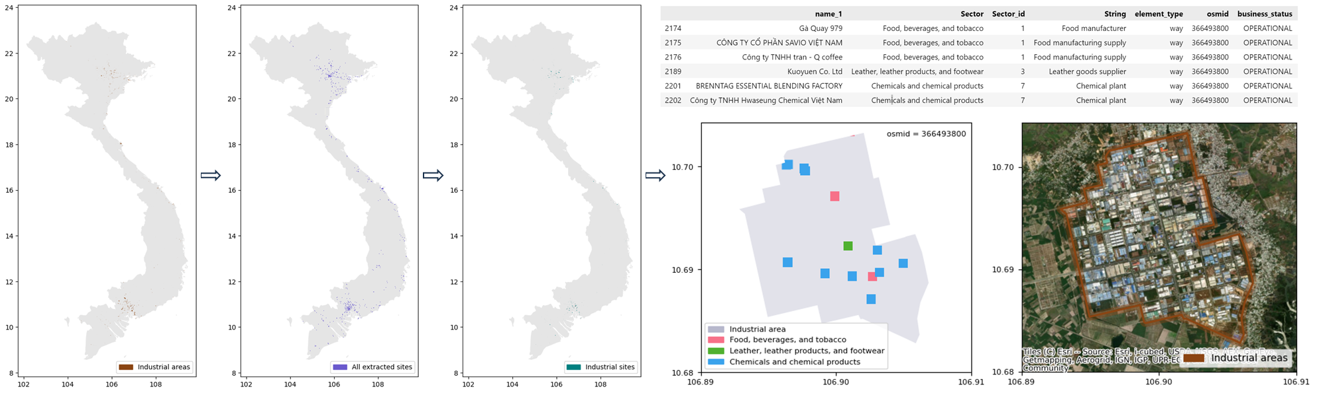
Figure 5

3.2 Add information to loads
Input data includes OSM land-use sites (industrial areas), retrieved economic activities, nodes from simplified network, electricity demand statistics.
We consider industrial areas with economic activities as loads rather than considering individual economic activities. We perform the following operations on economic activities and industrial areas:
- Allocate the total electricity demand in statistics to all economic activities equally by sector.
- Group economic activities with their corresponding land-use sites and calculate the total electricity demand for all economic activities within each land-use site.

3.3 Connection between loads and the network
(Manuscript) This procedure aims to map the intricate interdependencies between business activities and the power grid elements upon which they rely. In current studies, the common approach is using Voronoi approach, where we fix a substation and find out which businesses lie within its service area. This approach is from the perspective of providers/suppliers. If a substation breaks down, all business activities located in its service area would be interrupted. However, if one substation breaks down, the power plants will regulate the amount of electricity generation, and the generated electricity will be reconfigured to other substations. The business activities are likely to receive electricity from other substations, which are nearby and have sufficient capacity.
The second approach, on the contrary, is from the perspective of users. We fix the location of business and search the substations around it and connect the substation to this business based on distance rank. We can even extend the second approach to a probabilistic-based method. We don’t know how substations and businesses are connected, but there are high chances that business will be connected to a closest substation, and similarly, it being connected to a farther substation is less likely. In addition, we can also consider other dimensions, which are hard to be included in Voronoi approach. Capacity of substations are different; some are larger than others, so they can provide more electricity power. We could consider capacity as a weight, then even though the second ranking closest substation is farther away, it may still be connected to the business because the first ranking small substation is already to full capacity.
There are certain conditions that more or less likely to be connected to one substation of the other, for example, geography. We could consider administrative boundaries/providers’ service areas. We assume that there is a business lies on the border of service areas between two regional providers A and B, relying on provider A. Even if the business is closer to a substation within the provider B, it should still get connected to a farther substation within provider A. On an international level, national boundaries are the ones, but not sure provincial boundaries would be a limit. In some cases, like the US, Texas will not be connected to the rest of the country because they have their own grid.
Therefore, we propose a novel probability-based approach for coupling substations and businesses. The likelihood of a business being connected to a certain substation is determined by both the distance and the capacity of the substations.
We perform the following steps to connect land-uses sites (industrial areas) to the network:

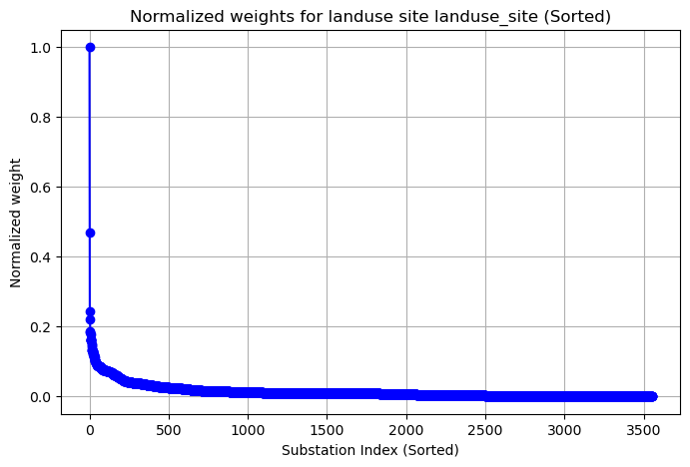
Figure 6

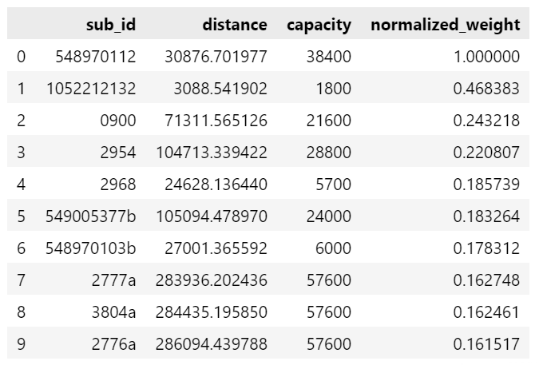
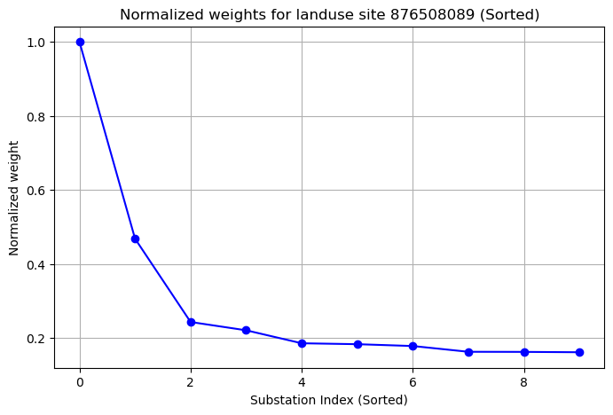
Figure 7
Figure 8. Consider top 10 nodes within 60 km for industrial area ‘876508089’.
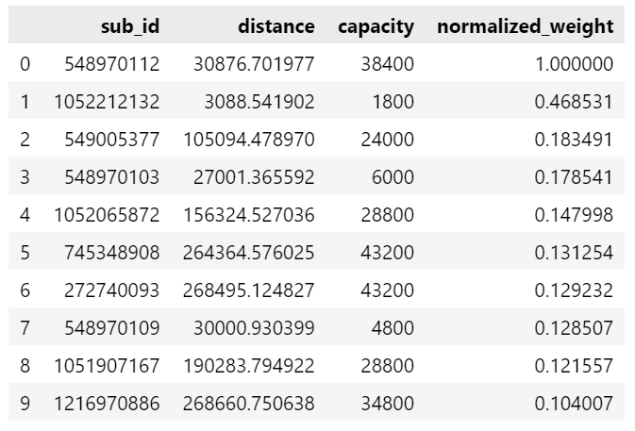
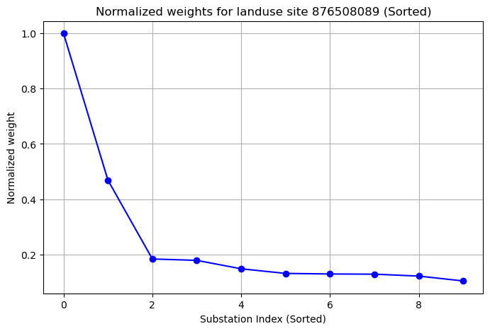
Figure 9. Consider top 10 substations within 60 km for industrial area ‘876508089’.

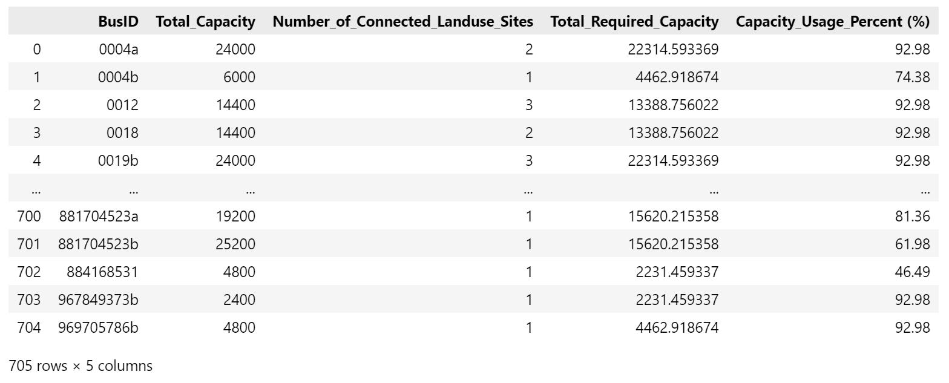
Figure 10. Percentage of substation capacity occupied

QUESTIONS:
- Should we only consider real substations in the nodes or consider all nodes as substations? Some nodes are the end nodes of transmission lines, representing pylons from the satellite imagery.
- How many nodes do we consider as candidates (get_top_subs())? Fewer candidates increase the likelihood that an industrial area will not be connected to any node.
- Distance threshold

4 Power flow model
pandapower, PyPSA, etc
Revised from 5_create_power_flow_model.ipynb
Final network:
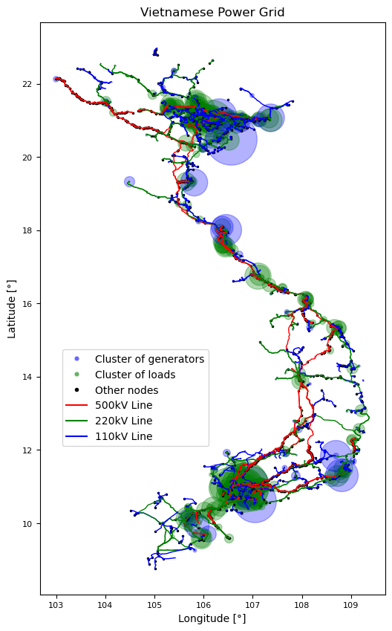
Figure 11

4.1 Introduction to pandapower

4.2 Assumptions
transformers, switches, etc.

4.2.1 Generators or static generators?
Estimate peak demand of generators:
The peak demand can be estimated based on the generator's rated capacity. Typically, the peak demand ranges from 80% to 100% of the rated capacity. For example:
$$Peak demand=Capacity×0.9$$

4.2.2 Steps to Estimate Peak Demand from Annual Energy Consumption (GWh)
To calculate the Peak Demand (p_mw) of a load from annual energy consumption (in GWh), follow these steps:
1. Convert Annual GWh Consumption to MW
The annual energy consumption in GWh represents the total energy consumed over the entire year. To estimate Peak Demand, you need to derive the maximum power demand (p_mw).
Assuming the load's consumption is evenly distributed across the year, calculate the average hourly consumption and then estimate the peak power demand.
2. Calculate Average Hourly Power Consumption (MW)
Assume a year has 8760 hours (24 hours × 365 days). Convert the annual consumption in GWh to average hourly power consumption in MW using the formula:
$$Average Hourly Power \left(MW\right)=\frac{Annual Consumption (GWh)}{24×365}×1000$$
3. Estimate Peak Demand
The peak demand is typically higher than the average power due to peak usage times. You can estimate the peak demand as 1.5 to 2 times the average hourly power consumption:
$$Peak Demand \left(MW\right)=Average Hourly Power (MW)×1.5$$

4.3 Pandapower network
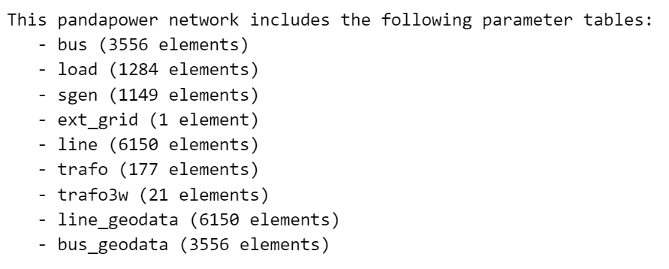
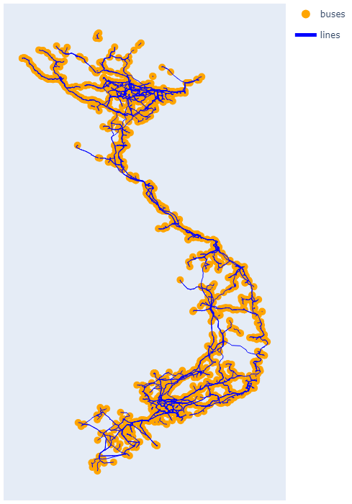
Figure 12

5 Percolation analysis

5.1 Remove xx%

5.2 Remove one-by-one until the whole network fails

5.3 Overlap with hazard maps

Data source: https://ember-energy.org/data/yearly-electricity-data/
Calculated from Vietnam Energy Statistics: (Capacity of FO fired + Capacity of Diesel) / 1000.

